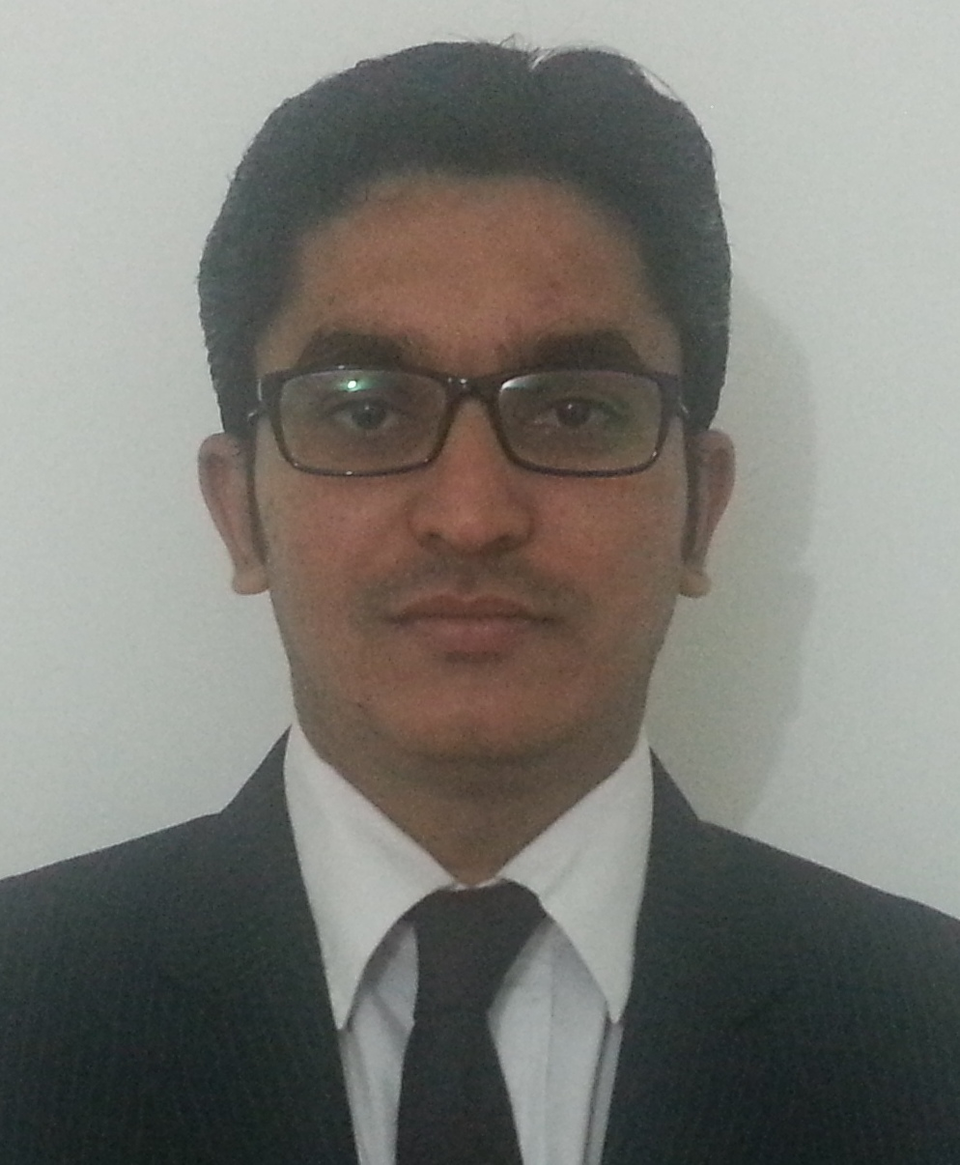
RAVIRAJ K. GAUTAM

At Post-dhundi, Tal-Pusad ,Dist-yavatmal
Pin Code-445204
Mobile :08275287539
E-mail: thakur.raviraj@gmail.com
Specialization: Marketing

Education:

MBA Indira Institute of PUNE University 2012-2014 Pursuing
(Marketing) Management,Pune

B.E. K. K. Wagh College Pune University 2004-2010 60%
(Chemical) of Engg, Nashik

HSC P. N. College Maharashtra State 2002-2004 60%
(Science) Pusad Board

SSC M.P.N. Convent Maharashtra State 2002 62%
Pusad Board

Project Details:

Company : Fair Mate Construction Chemicals, Vadodara
Project Title : Market research of potential for Construction Chemicals in Modern Civil Engineering across Pune Region
Duration : Two months
Details:
    - Studied and understood the company product.
    - Successfully completed the market survey to find out the market share.
    - Understood the overall marketing activities of Construction Chemicals products.
    - Introduced products to the prospective customers.

Achievements:
- Closed 8 deals which brought revenue of around Rs.18000 to company

Computer Skills:
Operating Systems: Windows, DOS
Packages Known: MS Office (Word, PowerPoint, Excel)

Additional Qualification:
- Successfully completed DALE CARNEGIE programme on Sales and Marketing
    - Prospecting
    - Rapport Building
    - Presenting Solutions
    - Attitudes for Services
    - Complaint Resolution
- Successfully completed “Business Proficiency Skills Programme” organized by ISIL and SpeakFirst, Pune

- Currently undergoing a 250-hour comprehensive Performance-based Leadership Development Programme by Stratecent Consulting, and have acquired the following skills:

- Negotiation Skills
- Problem Solving Skills
- Systems Thinking
- SPIN Selling
- Strategy
- Teams

Accomplishment:
Awarded 2nd Prize for B-Plan Competition organized by TiE’13, Pune

Extra Curricular Activities
- Training in Bharat Petroleum Corporation Limited (BPCL)
- Worked as Joint Secretary of ACES(Association Of Chemical Engineering Student)
- Participation at Division level Badminton Competition held at Amravati
- Active participation in sports such as Cricket and Carom

Personal Details:
Date of Birth : 12/03/1986
Marital Status : Single
Strengths:
- Analytical skills
- Interpersonal skills
- Perseverance & Patience

Languages : English, Hindi, Marathi

